**ASSIGNMENT - 4**

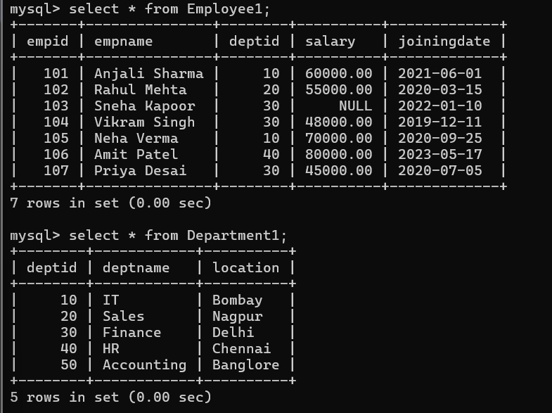

--------------------------------------------------------------------------------------------------------

1. Write a query to calculate the total salary of all employees.

Ans:-

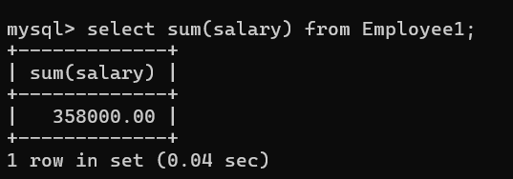

------------------------------------------------------------------------------------------------

1. Write a query to find the average salary of employees in each department using GROUP BY.

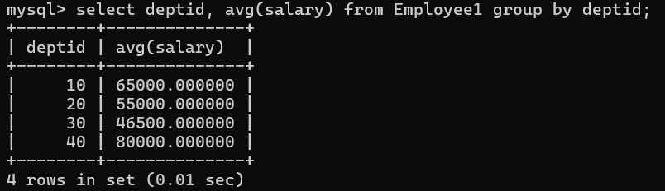

-----------------------------------------------------------------------------------------------------

1. Write a query to count the total number of employees in each department.

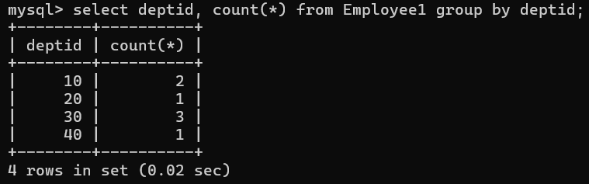

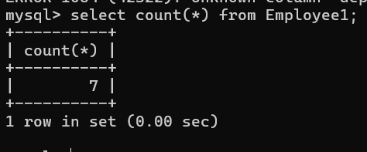

--------------------------------------------------------------------------------------------------------

1. Write a query to display departments having more than 5 employees using HAVING clause.

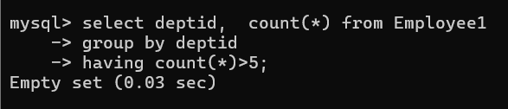

--------------------------------------------------------------------------------------------------------

1. Write a query to list distinct department locations from the Dept table.

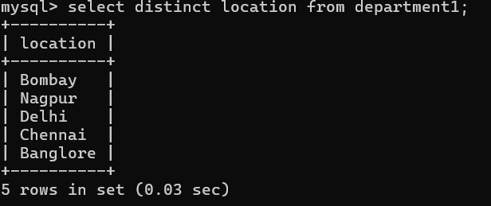

--------------------------------------------------------------------------------------------------------

1. Write a query to display the highest salary among all employees. Write a query to display all total number of employee in table.

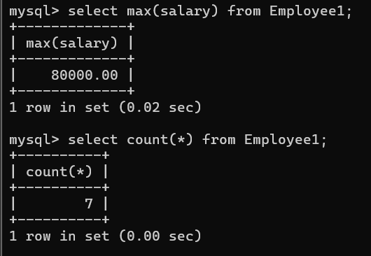

----------------------------------------------------------------------------------------------------

1. Write a query to find employees whose name starts with 'A' using LIKE operator.

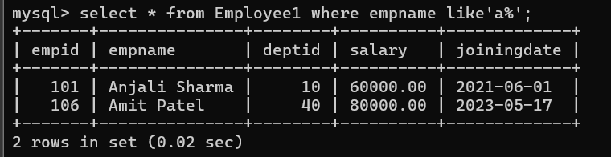

--------------------------------------------------------------------------------------------------------

1. Write a query to find employees whose name ends with 'n' using LIKE operator.

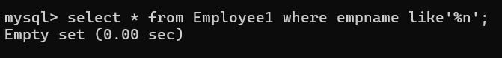

-------------------------------------------------------------------------------------------------

1. Write a query to find employees whose name contains 'ra' using LIKE operator.

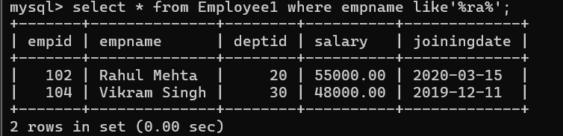

--------------------------------------------------------------------------------------------

1. Write a query to display all employees sorted by their Salary in descending order.

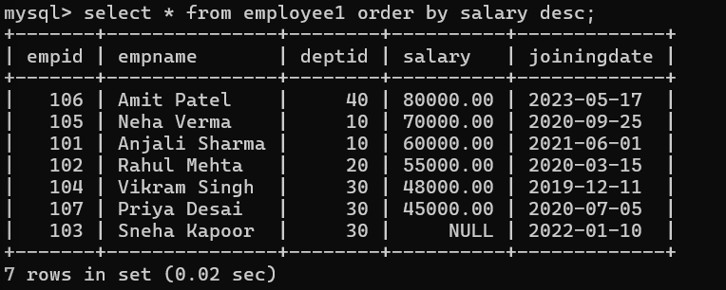

------------------------------------------------------------------------------------------------

1. Write a query to display all employees sorted by DeptID ascending and then Salary descending.

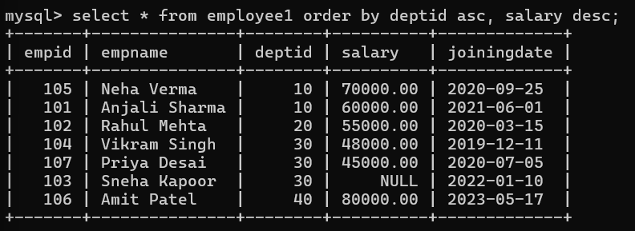

----------------------------------------------------------------------------------------------------

1. Write a query to find employees whose salary is between 30,000 and 60,000.

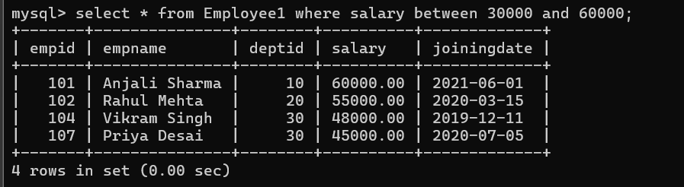

----------------------------------------------------------------------------------------------------

1. Write a query to display all employees whose DeptID is in (10, 20, 30).

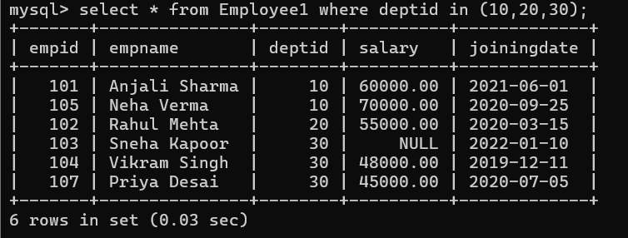

----------------------------------------------------------------------------------------------------

1. Write a query to display Min salary of employee .

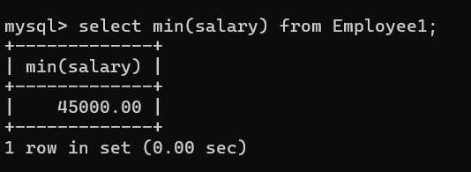

----------------------------------------------------------------------------------------------------

1. Write a query to display employees whose JoiningDate is between '2020-01-01' and '2021-12-31'.

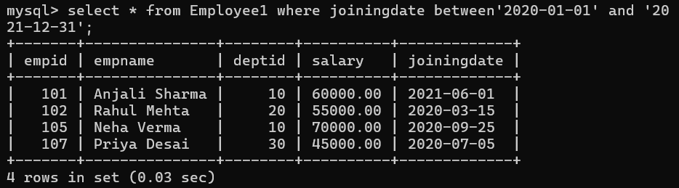

----------------------------------------------------------------------------------------------------

1. Write a query to display employees whose Salary is NULL.

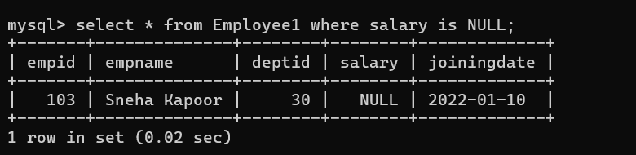

----------------------------------------------------------------------------------------------------

1. Write a query to display employees whose Salary is NOT NULL.

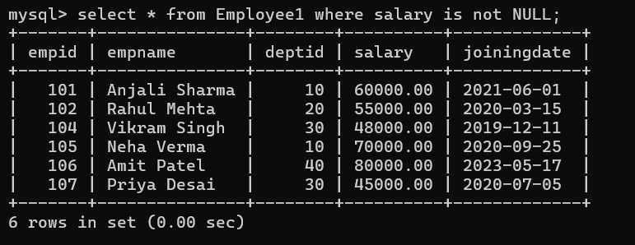

----------------------------------------------------------------------------------------------------

1. Write a query to calculate the total salary per department, but only for departments where total salary is greater than 1,00,000 (use HAVING).

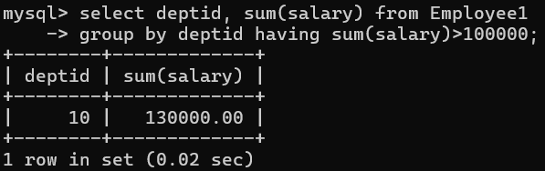

----------------------------------------------------------------------------------------------------

19. Write a query to display all distinct employee names.

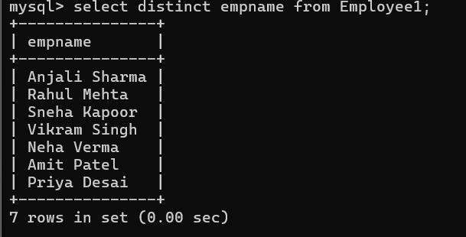

----------------------------------------------------------------------------------------------------

20.Write a query to count the number of departments having the same location.



